UNIVERSITY OF DAR ES SALAAM



COLLEGE OF INFORMATION AND COMMUNICATION TECHNOLOGIES (CoICT).

DEPARTMENT OF ELECTRONICS AND TELECOMMUNICATION ENGINEERING.

ES 499: FINAL YEAR PROJECT

PRESENTATION NOTES

|  |  |
| --- | --- |
| PROJECT TITTLE: | WI-FI ENABLED SECURED USB FLASH DRIVE |
| STUDENT`S NAME: | KOWERO, WALIDI WAZIRI |
| REG. NO: | 2020-04-04390 |
| PROGRAM: | BSc. IN ELECTRONICS ENGINEERING |
| SUPERVISOR`S NAME: | PROF BARAKA MAISELI. |
|  |  |
|  |  |
|  |  |

# INTRODUCTION

This project aims at utilizing this advancement in technology that we have achieved so far to develop a secured wireless system that can perform seamless data transfer to the client over different operating systems. The system tries to increase the mobility and freedom and provide more options to the user towards the access of information.

# OBJECTIVES

## Main objective

To enhance flexibility and security in wireless flash storage devices.

## Specific Objectives

1. To enable reliable wireless data transfer
2. To implement secure ways of data transfer
3. To implement multipoint user-friendly interfaces

# FUNCTIONAL HARDWARE REQUIREMENT

This system is composed of the following

1. Usb interface connector
2. Wi-Fi radio
3. ESP32S3 Controller
4. SD_MMC Nand based memory
5. Battery
6. Charge controller

# FUNCTIONAL BLOCK DIAGRAM

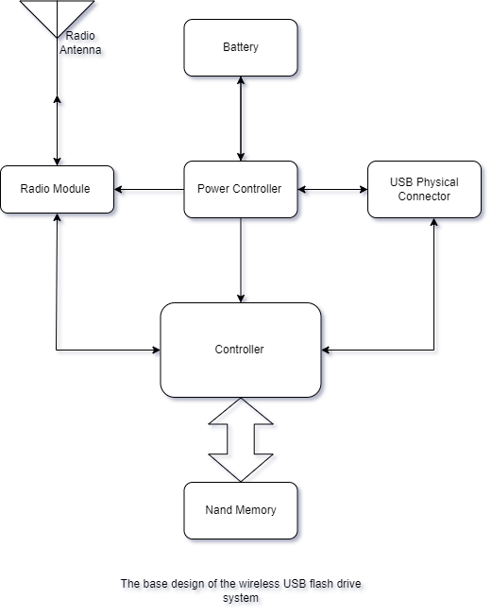

# SYSTEM FLOWCHART

